THE UPRISING OF DIABETES
Early detection and prevention
Wilson, Damian T
10-27-2024
Cal State University, Los Angeles
CIS 5250

INTRODUCTION
As Diabetes is a well-known chronic illness many people fail to understand what the illness is about and how to manage it. Diabetes is an autoimmune disease in which the body attacks itself and destroys the pancreas which produces insulin to manage a regular blood sugar level. As diabetes destroys the pancreas, insulin is not able to be produced in the body and that person becomes diabetic. Diabetes doesn’t also just destroy the pancreas, but over time it breaks down other body functions which most diabetics suffer from amputation, heart disease, kidney disease, Neuropathy (Nerve Damage), ED, and many other things that lead to depression. As I have a person connection because I am a type one diabetic since the age of 6, I’ve had diabetes for over 27years, and I’m still not use to the daily adventures I face with having this autoimmune disease. Many days I’m feeling sick even when I try to take care of myself the way I’m supposed to. As many people fail to understand that diabetes manifests in our younger age whether its type 1 or type 2 if we can establish more knowledge this disease could be prevented or even well controlled for the ones who have the disease.
As I read many articles and seen videos, I’ve seen a growth in people obtaining diabetes. There are 3 different types of diabetes. As stated on the website, IDF.org, “By 2045, IDF projections show that 1 in 8 adults, approximately 783 million, will be living with diabetes, an increase of 46%.” (IDF.org, May 2024). As many factors play a role in getting diabetes as in type 2 and pregnancy diabetes, which could be cured if following the right health choices, as to the article on page 16 refers to many factors that play a role in people getting diabetes as in less physical activity, smoking and drinking, salt consumption, High blood pressure, weight just to name a few issues that could lead to diabetes (WHO,2015). There are many factors that can help type 1 diabetics manage a better life, but for type 2 and gestational aka Pregnancy diabetes can always be reversed if you follow specific guidelines (embecta.com). As I suffer from many complications, and I don’t want others to suffer so if they could make lifestyle changes to prevent this disease, I would share information available and my personal point of view.
Dataset(s)/ Data source URL: Diabetes Health Indicators Dataset (kaggle.com)
Data Description
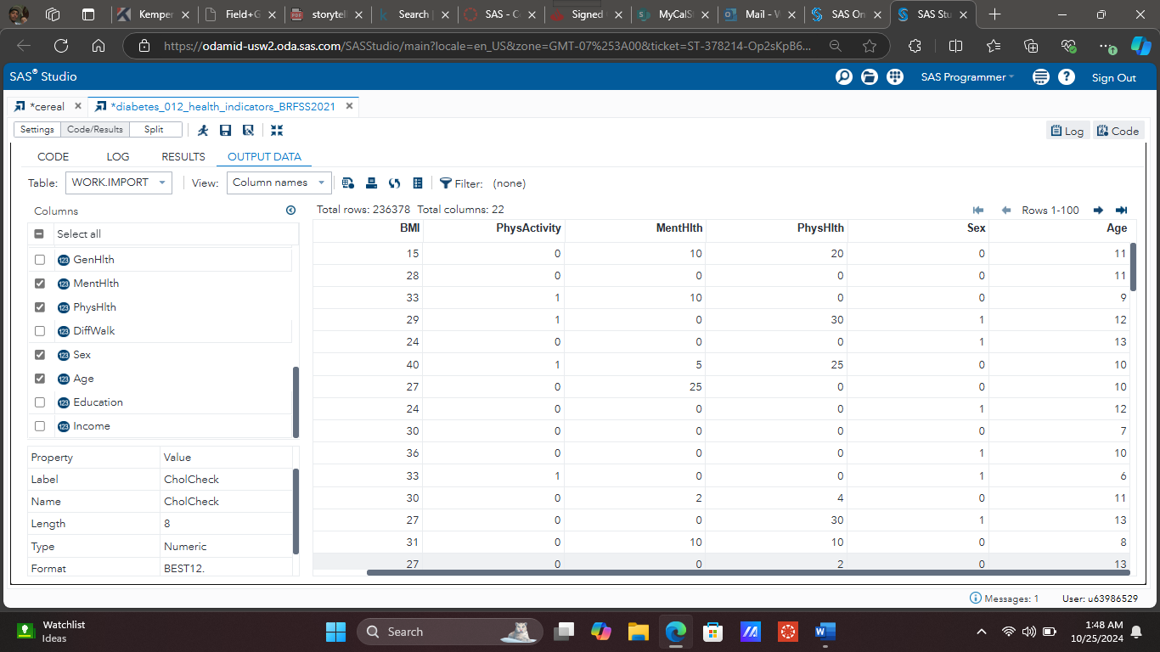
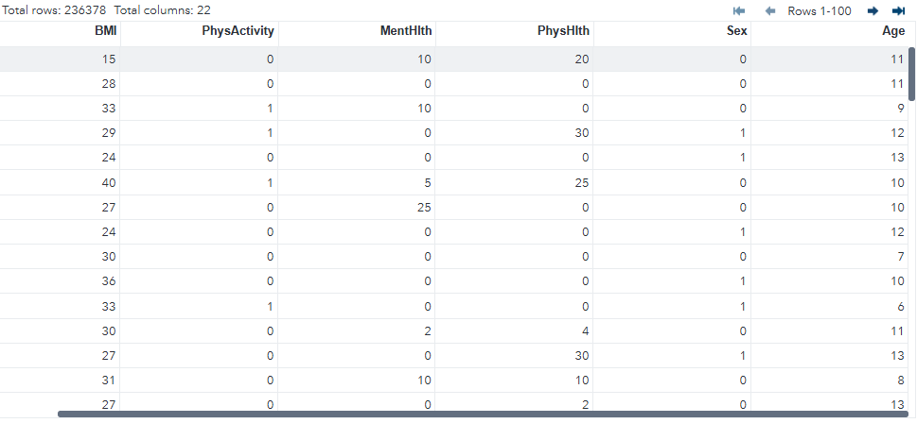

Field Name: Body Mass Index (BMI) | Description: It measures the body fat of an individual, as it’s used to screen the individual to see if they are at risk for certain diseases.
Field Name: Physical Activity (PhysActivity) | Description: The overall health of weight management, food consumption as well as any other aspect that can refer to a individual’s physical health.
Field Name: Mental Health (MentHlth) | Description: Evaluates the mental status of the individual.
Field Name: Sex | Description: The specific gender identity of the individual to understand the differences between the two genders. Males are represented as 1. Females are represented as 0.

Field name: Age | Description: The age of the individual that does or doesn’t have diabetes.
Field name: PhysHlth | Description: The overall physical health of the individual who has diabetes, but according to the information studied most of the individuals are children, which could majority result in Type 1 Diabetes which is called “Juvenile diabetes”. Type 2 which could be due to multiple factors as in Age, BMI, Diet etc. As most adults suffer from Type 2 Diabetes, children can get it also.

Analysis & Visualizations
- How can we establish prevention and get people aware of the uprising of Diabetes?

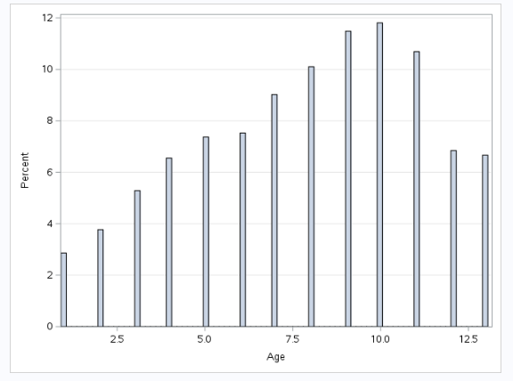

Explanation:
Establishing effective prevention strategies and raising awareness about the rising prevalence of diabetes requires a multifaceted approach that involves education, community engagement, and policy initiatives. Public health campaigns can play a crucial role in informing people about the risk factors associated with diabetes, such as obesity, sedentary lifestyle, and poor dietary habits. Schools, workplaces, and healthcare facilities can implement programs that promote healthy eating, regular physical activity, and routine health screenings. Collaborating with local organizations, health professionals, and influencers can amplify these messages and reach diverse populations, particularly those at higher risk for diabetes (WHO, April 2023). Tailoring programs to address cultural and socioeconomic factors can enhance their effectiveness and ensure greater participation.
Moreover, leveraging digital platforms and social media can broaden the reach of diabetes awareness initiatives. Interactive tools, such as mobile apps that track physical activity and nutrition, can empower individuals to take charge of their health. Additionally, policymakers should prioritize funding for diabetes prevention programs and ensure access to affordable healthcare services, which can include preventive screenings and educational resources. Addressing the social determinants of health—such as access to healthy foods and safe spaces for exercise—will be essential in curbing the diabetes epidemic. By combining education, community support, and policy advocacy, we can create a comprehensive strategy to reduce the incidence of diabetes and improve overall public health.


- What is the association between age and diabetes prevalence with overall physical Health? 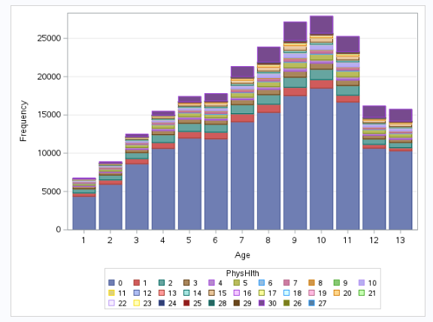

Explanation:
The association between age and diabetes prevalence among children aged 1 through 13 is marked by increasing concerns about the rising incidence of type 2 diabetes in this population. Traditionally, type 1 diabetes has been the more common form diagnosed in younger children, but there is a concerning trend of type 2 diabetes emerging due to factors such as obesity, sedentary lifestyles, and poor dietary habits. As children age, especially during the transition from early childhood to adolescence, they may experience weight gain and decreased physical activity, which can significantly raise their risk for developing type 2 diabetes. Furthermore, the metabolic changes associated with puberty can also affect insulin sensitivity, increasing the likelihood of diabetes in susceptible children.
Overall physical health in this age group is intricately linked to diabetes risk. Children who are physically active and maintain a balanced diet are less likely to become overweight, which is a major risk factor for type 2 diabetes. Encouraging regular physical activity and healthy eating habits from an early age can help prevent obesity and reduce the prevalence of diabetes (Zhang, August 2024). Schools and communities can play a vital role by providing access to safe play areas, physical education programs, and nutritional education. Early intervention is critical, as addressing these factors in childhood not only helps mitigate the risk of diabetes but also promotes lifelong healthy habits, contributing to better overall physical health.

- How does physical activity level impact diabetes prevalence in different age groups?

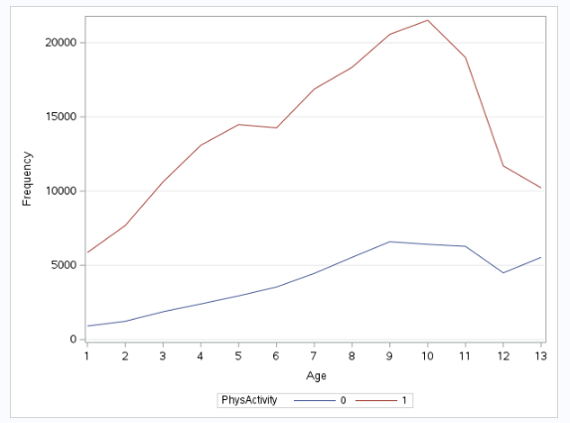
Non-Physical activity=0, Physical activity=1

Explanation:
Physical activity levels significantly impact diabetes prevalence among children aged 1 to 13, influencing both the development of type 1 and type 2 diabetes. Engaging in regular physical activity helps maintain a healthy weight, which is crucial since obesity is a major risk factor for type 2 diabetes in children. During early childhood, ages 1 to 5, active play promotes not only physical health but also motor skills and social interaction. However, as children grow older and enter school, sedentary behaviors, such as screen time, often increase, leading to a decline in physical activity. Studies have shown that children who participate in structured physical activities or sports exhibit lower rates of insulin resistance and improved metabolic profiles, which are protective against the development of diabetes.
For children aged 6 to 13, the relationship between physical activity and diabetes becomes even more pronounced. Research indicates that regular physical activity can enhance insulin sensitivity and reduce body fat, both of which are vital in preventing type 2 diabetes. Furthermore, encouraging active lifestyles through school programs and community initiatives has been associated with lower diabetes prevalence. The Centers for Disease Control and Prevention (CDC) and the American Diabetes Association highlight the importance of integrating physical activity into daily routines to combat rising diabetes rates among youth. Increased awareness and intervention strategies targeting physical activity can significantly mitigate the risk of diabetes in these age groups. The lack of physical activity leads to higher rates of males and females to get diabetes between the ages of 1-13.

- What is the relationship between BMI and diabetes prevalence across different sexes?

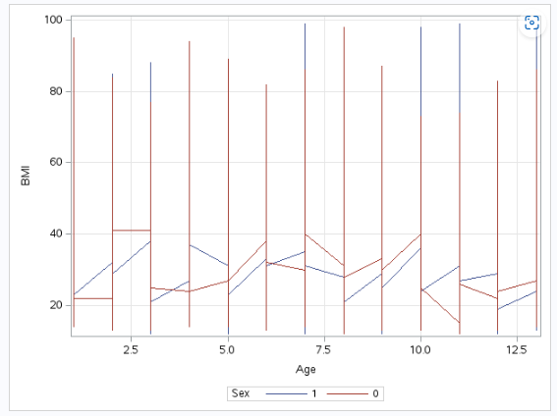

Explanation:
The relationship between Body Mass Index (BMI) and diabetes prevalence in children aged 1 to 13 varies significantly across sexes due to biological, behavioral, and social factors. In general, higher BMI is associated with increased risk of type 2 diabetes, particularly as children transition into adolescence (Bay, May 2007). Studies indicate that boys and girls may exhibit different BMI trajectories, with boys often having higher rates of overweight and obesity at younger ages. This difference can lead to varying prevalence rates of diabetes. For instance, research shows that while both sexes are at risk, girls may develop insulin resistance earlier, partly due to hormonal changes, which can affect their long-term risk for type 2 diabetes.
Additionally, the societal context and lifestyle factors influencing physical activity levels and dietary habits can further complicate the relationship between BMI and diabetes prevalence across sexes. Boys are often encouraged to engage in more vigorous physical activity, while girls may face societal pressures that limit their engagement in sports or physical play. This can result in a higher incidence of overweight and obesity among boys, but increased health risks among girls when BMI is elevated. A study published in Diabetes Care highlighted these disparities, noting that sex-specific interventions may be necessary to effectively address the rising rates of diabetes in children, with tailored strategies for promoting healthy weight and activity levels.

Statistical Summary



Explanation:
When comparing the two sexes of females and males based on the data, several notable differences emerge, particularly in terms of mean scores and variability. The female group, with a mean of 7.94, shows a slightly higher average than the male group, which has a mean of 7.78. This difference suggests that, on average, females in this population are prevalent to have higher risks of diabetes compared to males. Additionally, the standard deviation for females (3.21) is slightly lower than that for males (3.263), indicating that for females are more tightly clustered around the mean. As women can have a higher chance of getting diabetes as the could get type 1 type 2 or gestational diabetes which males cant get gestational diabetes
In terms of distribution, both groups share the same minimum and maximum values (1.000 to 13.0), indicating that both sexes encompass the same range of scores. However, the larger sample size for females (123,431) compared to males (112,947) could contribute to more reliable statistical estimates for the female. The higher mean and lower standard deviation for females might imply that targeted interventions or educational strategies could be more effective in this population, given their more consistent performance to make changes. In contrast, the broader variability in male scores suggests that there may be a more diverse range of abilities or needs that males need, potentially indicating areas for targeted support or improvement to make changes to prevent diabetes (Simmons, October 2022).

One-Way Frequency

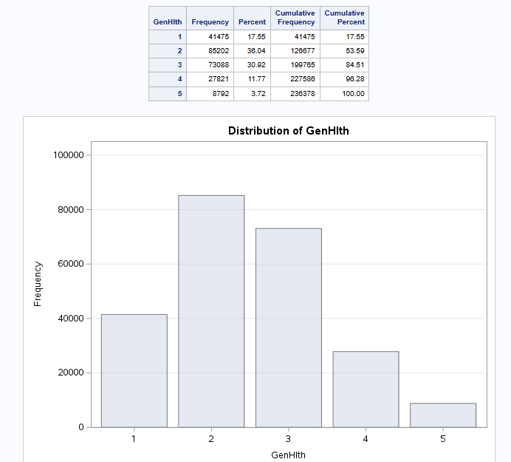

Explanation:
Over time, diabetes can have a profound negative impact on various systems in the body, primarily due to elevated blood sugar levels. Chronic hyperglycemia can lead to complications such as cardiovascular disease, as high glucose levels damage blood vessels and increase the risk of heart attacks and strokes. Additionally, diabetes can impair kidney function, leading to diabetic nephropathy, which may eventually require dialysis or transplantation. The eyes are also affected, with the risk of diabetic retinopathy increasing, potentially resulting in vision loss. Nerve damage, or diabetic neuropathy, can cause pain, tingling, and loss of sensation, particularly in the extremities, increasing the risk of injuries and infections. Furthermore, poor blood flow can slow healing processes and contribute to foot ulcers, which may lead to serious infections. Overall, the systemic effects of diabetes highlight the importance of effective management to mitigate these long-term complications.
As the data provided it shows that overtime whether male or female diabetes affects both sexes overtime. I can confirm this through my own personal view as I am type 1 diabetic. I have had it since I was six years old, and my parents were in control for my younger years until I became a teen. As I didn’t take care of myself like I should I didn’t understand how diabetes affects a lot of different body functions and now as a 33-year-old man I suffer from a lot of issues that I could have prevented or slowed down as Diabetes slowly destroys the body overall. So, this data shows that overtime general health would drastically go down. I even knew diabetics that took care of themselves yet still struggle with issues as I do.

Correlation Analysis

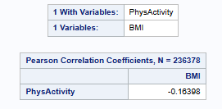

Explanation:
The correlation analysis between physical activity and BMI yields a Pearson correlation coefficient of -0.16398, based on a sample size of 236,378. This negative correlation indicates a weak inverse relationship between the two variables, suggesting that as physical activity levels increase, BMI tends to decrease. While this correlation is statistically significant, its magnitude suggests that other factors may also play a substantial role in influencing BMI. For instance, while higher physical activity is associated with lower BMI, lifestyle choices, dietary habits, and genetics also significantly impact an individual's body weight, composition and risks of getting diabetes.
Furthermore, this finding underscores the importance of promoting physical activity as a public health strategy to combat obesity and the correlation with Diabetes. Although the correlation is weak, it aligns with existing literature that highlights the benefits of regular exercise in managing weight and improving overall health. Encouraging individuals to engage in physical activity can lead to better weight management, which is crucial in reducing the risk of diabetes, including cardiovascular disease. However, it is essential to consider that interventions aimed at reducing BMI should take a comprehensive approach, addressing not only physical activity but also nutrition and behavioral factors to achieve more significant and sustainable outcomes.

Works Cited
“Facts & Figures.” International Diabetes Federation, 7 May 2024, idf.org/about-diabetes/diabetes-facts-figures/.
Who, World Health Organization (WHO), 2015, Pg16 iris.who.int/bitstream/handle/10665/204871/9789241565257_eng.pdf;jsessionid=1C37B06DC80E86F04A020FC9CEDC7113?sequence=1.
“Welcome to the EMBECTA Resource Hub.” Education & Resources, go.embecta.com/EducationandResources?msclkid=8c43150f2a4b136b131873f4730d7b23&utm_source=bing&utm_medium=cpc&utm_campaign=Non+Brand+N2G+Email+Signup+Campaign_DTP_Phrase&utm_term=diabetes+treatment&utm_content=Non+Brand+Care. Accessed 30 Sept. 2024.
“Diabetes.” World Health Organization (WHO), World Health Organization, 5 Apr. 2023, www.who.int/news-room/fact-sheets/detail/diabetes.
Zhang, Yunqing, et al. “Association between Physical Activity Level and Diabetes Incidence among Chinese Middle-Aged and Older Adults: A Cross-Sectional Study from the China Health and Retirement Longitudinal Study.” Frontiers in Public Health, U.S. National Library of Medicine, 9 Aug. 2024, pmc.ncbi.nlm.nih.gov/articles/PMC11341424/.
Simmons, Hannah. “Diabetes in Men versus Women.” News, 11 Oct. 2022, www.news-medical.net/health/Diabetes-in-Men-versus-Women.aspx.
Bays HE, Chapman RH, Grandy S; SHIELD Investigators' Group. The relationship of body mass index to diabetes mellitus, hypertension and dyslipidaemia: comparison of data from two national surveys. Int J Clin Pract. 2007 May;61(5):737-47. doi: 10.1111/j.1742-1241.2007.01336.x. Erratum in: Int J Clin Pract. 2007 Oct;61(10):1777-8. PMID: 17493087; PMCID: PMC1890993.

